Sorting Algorithm
- Merge Sort
#include<bits/stdc++.h>

using namespace std;

void merge(vector<int>& arr, int low, int mid, int high){
vector<int> temp; // Temporary array to store merged result
int left = low; // Pointer for the left subarray
int right = mid+1; // Pointer for the right subarray

// Merge the two subarrays into temp[]
while(left <= mid && right <= high){
if(arr[left] <= arr[right]) temp.push_back(arr[left++]);
else temp.push_back(arr[right++]);
}

// Copy remaining elements
while(left<= mid) temp.push_back(arr[left++]);
while(right <= high) temp.push_back(arr[right++]);

for(int i=low; i<=high; i++) arr[i] = temp[i-low];
}

void mergeSort(vector<int>& arr, int low, int high){
if(low >= high) return; //Base case: single element is already sorted
int mid = (low + high)/2;

// Recursively sort the left half
mergeSort(arr,low,mid);

// Recursively sort the right half
mergeSort(arr,mid+1,high);

// Merge the two sorted halves
merge(arr,low,mid,high);
}

int main(){
vector<int> arr = {9,8,7,6,5,4,3,2,1};
cout<<arr.size()-1<<endl;
mergeSort(arr,0,arr.size()-1);

for(auto it : arr) cout<<it<<" ";
}

Time Complexity: - O (n logn)
Space Complexity: - O(n)

- Quick Sort

Steps:
- Pick a pivot element. (Pivot can be any element)
- Smaller on left, Larger on right.
  - i -> smaller element than pivot
  - j -> greater element than pivot
  - if(i<j) swap(arr[i],arr[j])
  - if not exit loop and swap arr[low] to arr[j]
- Repeat
// Partition function to place pivot in the correct position
int partition(vector<int>& arr, int start, int end){
int i = start; // Left pointer
int j = end; // Right pointer
int pivot = arr[start]; // Choosing the first element as the pivot

// Loop until the two pointers meet
while(i < j){
// Move 'i' right until an element greater than pivot is found
while(arr[i] <= pivot && i<end) i++;

// Move 'j' left until an element less that pivot is found
while(arr[j] > pivot && j>start) j--;

// If 'i' is still left of 'j', swap the elements at i and j
if(i<j) swap(arr[i],arr[j]);
}
// Swap the pivot
swap(arr[start],arr[j]);
return j;
}

void qs(vector<int>& arr, int start, int end){
if(start < end){
// Partition the array and get the pivot index
int pIndex = partition(arr,start,end);

// Recursively sort the left and right subarrays
qs(arr,start,pIndex-1);
qs(arr,pIndex+1,end);
}
}

Time Complexity: - O (n logn)
Space Complexity: - O(1)

- Selection Sort
- select the minimum element from the range.
- we will swap the minimum element with the first element.
vector<int> arr = {9,8,7,6,5,4,3,2,1}; //Linear code
int n = arr.size();
for(int i=0; i<n; i++){
int mini = i;
for(int j = i; j<n; j++){
if(arr[j] < arr[mini]) mini = j;
}
swap(arr[mini],arr[i]);
}
void SelectionSort(vector<int>& arr, int n, int i){ //recursive code
if(i == n ) return; // base case
//hypothesis
int mini = i;
for(int j = i; j<n; j++){
if(arr[j] < arr[mini]) mini = j;
}
swap(arr[mini],arr[i]);
//induction
SelectionSort(arr,n,i+1);
}

- Insertion Sort
- Pick the starting element and check all element to its right.
- If the element is smaller than swap all the smaller element
for(int i=0; i<n; i++){ //Linear code
int j = i;
while(j>0 && arr[j] < arr[j-1]){
swap(arr[j],arr[j-1]);
j--;
}
}

void InsertionSort(vector<int>& arr, int n , int i){ //Recursive code
//base case
if(i == n) return;
//hypothesis
int j = i;
while(j>0 && arr[j-1] > arr[j]) {
swap(arr[j],arr[j-1]);
j--;
}
//Induction
InsertionSort(arr,n,i+1);
}

- Merge Sort
- Compare each pair of adjacent elements, and swap them if they are in the wrong order.
- Repeat this process for all elements until the entire list is sorted.

for(int i= 0; i<n-1; i++){ //Linear code
for(int j = 0; j < n-i-1; j++){
if(arr[j] > arr[j+1]) swap(arr[j],arr[j+1]);
}
}

void BubbleSort(vector<int>& arr, int n, int i){ //Recursive code
//base case
if(i == n-1) return;

//hypothesis
for(int j= 0; j< n-i-1; j++){
if(arr[j] > arr[j+1]) swap(arr[j],arr[j+1]);
}
//Induction
BubbleSort(arr,n,i+1);
}

Time Complexity: - O (n^2)
Space Complexity: - O(1)

Array Algorithms

- Dutch National Flag Algorithm - Basic Steps
The Dutch National Flag Algorithm is used to sort an array containing three distinct elements (commonly 0s, 1s, and 2s). It efficiently partitions the array into three sections:
- Elements less than the pivot (0s)
- Elements equal to the pivot (1s)
- Elements greater than the pivot (2s)

Steps:
- Initialize Three Pointers:
  - low (starting boundary for 0s)
  - mid (current element being processed)
  - high (ending boundary for 2s)
- Iterate through the array using mid pointer:
  - If arr[mid] == 0:
    - Swap arr[mid] with arr[low]
    - Increment both low and mid
  - If arr[mid] == 1:
    - No swap needed
    - Simply increment mid
  - If arr[mid] == 2:
    - Swap arr[mid] with arr[high]
    - Decrement high
    - Do not increment mid (because the swapped element needs to be checked)
- Repeat until mid crosses high.

Time Complexity:
- O(N) (Single pass through the array)

Code:
int low = 0, mid = 0, high = nums.size()-1;
for(int i=0; i<nums.size(); i++){
if(nums[mid] == 0){ swap(nums[low],nums[mid]);
mid++;
low++;}
else if(nums[mid] == 1) mid++;
else{ swap(nums[mid],nums[high]);
high--;}
}

- Moore's Voting Algorithm - Basic Steps
Moore’s Voting Algorithm is used to find the majority element (an element that appears more than ⌊N/2⌋ times) in an array in O(N) time and O(1) space.

Steps:
Phase 1: Find a Candidate
- Initialize two variables:
  - candidate = None (to store the potential majority element)
  - count = 0 (to track votes for the candidate)
- Iterate through the array:
  - If count == 0, assign arr[i] as the new candidate.
  - If arr[i] == candidate, increment count.
  - Otherwise, decrement count.
Phase 2: Verify the Candidate
- Count the occurrences of candidate in the array.
- If occurrences > ⌊N/2⌋, return candidate as the majority element.
- Else, return that no majority element exists.

Time Complexity:
- O(N) (Two passes: one to find the candidate, one to verify)
- O(1) Space Complexity

Code:
int n = nums.size();
int candidate = nums[0];
int cnt = 1;
for(int i=1; i<nums.size(); i++){
if(cnt == 0){
candidate = nums[i];
cnt = 1;
}
else if(candidate == nums[i]) cnt++;
else cnt--;
}
return candidate;

- Kadane’s Algorithm

Find the maximum sum of a subarray (a continuous part) from a given array of integers.

✨ Idea:
Instead of checking all subarrays, Kadane’s algorithm keeps track of the maximum sum ending at each position, and updates the global maximum if it finds a bigger one.

🔧 Steps:
- Start from the first element.
- At each step, either:
  - Add the current number to the previous sum (continue subarray), or
  - Start a new subarray from the current number — whichever is larger.
- Update the maximum sum seen so far.

int maxSubArray(vector<int>& nums) {
int maxSoFar = nums[0];
int sum = nums[0];

for (int i = 1; i < nums.size(); i++) {
sum = max(nums[i], sum + nums[i]);
maxSoFar = max(maxSoFar, sum);
}

return maxSoFar;
}

Binary Search Algorithm
- Standard Binary Search (Find an Element in a Sorted Array)

Binary Search is an efficient searching algorithm used to find an element in a sorted array in O(log N) time complexity.

Steps (Binary Search Approach)
- Initialize low = 0 and high = N - 1.
- Perform Binary Search:
  - Find mid = (low + high) / 2.
  - If arr[mid] == x, return mid (element found).
  - If arr[mid] < x, search in the right half (low = mid + 1).
  - If arr[mid] > x, search in the left half (high = mid - 1).
- If the loop ends, return -1 (element not found).
Code
int binarySearch(int arr[], int n, int x) {
int low = 0, high = n - 1;
while (low <= high) {
int mid = low + (high - low) / 2; // Prevent integer overflow
if (arr[mid] == x) return mid; // Element found
else if (arr[mid] < x) low = mid + 1; // Search right half
else high = mid - 1; // Search left half
}

return -1; // Element not found
}

- Lower Bound (First Position Greater Than or Equal to Target)
The lower bound of a value x in a sorted array is the first position where arr[i] ≥ x.
If x is present, it returns the first occurrence of x.
If x is not present, it returns the index where x should be inserted to maintain sorted order.
Steps (Binary Search Approach):
- Initialize low = 0, high = N - 1, and ans = N.
- Perform Binary Search:
  - Find mid = (low + high) / 2.
  - If arr[mid] ≥ x, update ans = mid and move left (high = mid - 1).
  - Else, move right (low = mid + 1).
- Return ans (index of lower bound).

Example:
arr = [1, 2, 4, 6, 8] x = 5
Lower bound = index 3

- Upper Bound (First Position Greater Than Target)
The upper bound of a value x in a sorted array is the first position where arr[i] > x.
If x is present multiple times, it returns the index after the last occurrence of x.
If x is not present, it returns the index where x should be inserted to maintain sorted order.
Steps (Binary Search Approach):
- Initialize low = 0, high = N - 1, and ans = N.
- Perform Binary Search:
  - Find mid = (low + high) / 2.
  - If arr[mid] > x, update ans = mid and move left (high = mid - 1).
  - Else, move right (low = mid + 1).
- Return ans (index of upper bound).

- First and Last Occurrence of an Element
Find the first and last index of a given element in a sorted array.
Modification:
  - Use binary search but continue searching left (high = mid - 1) for the first occurrence.
  - Use binary search but continue searching right (low = mid + 1) for the last occurrence.
Code
int lastOccurence(vector<int> arr, int tar){
int low = 0, high = arr.size()-1, ans = -1;
while(low<=high){
int mid = low + (high - low)/2;
if(arr[mid] == tar){
low = mid + 1;
ans = mid;
}
else if(arr[mid] < tar) low = mid + 1;
else high = mid - 1;
}
return ans;
}

int firstOccurence(vector<int> arr, int tar){
int low = 0, high = arr.size()-1, ans = -1;
while(low<=high){
int mid = low + (high - low)/2;
if(arr[mid] == tar){
high = mid - 1;
ans = mid;
}
else if(arr[mid] < tar) low = mid + 1;
else high = mid - 1;
}
return ans;
}

- Finding the Peak Element
An element is a peak if it is greater than its neighbors.
Binary Search Approach:
  - If arr[mid] is greater than both arr[mid - 1] and arr[mid + 1], return mid.
  - If arr[mid] < arr[mid + 1], move right (low = mid + 1).
  - Otherwise, move left (high = mid - 1).
Code
int peak(vector<int> arr){
int low = 1, high = arr.size()-2, n = arr.size();
if(n == 1) return arr[0];
if(arr[0] > arr[1]) return arr[0];
if(arr[n-1] > arr[n-2]) return arr[n-1];
while(low<=high){
int mid = low + (high - low)/2;
if(arr[mid] > arr[mid-1] && arr[mid] > arr[mid + 1]) return arr[mid];
else if(arr[mid] > arr[mid-1]) low = mid +1;
else high = mid - 1;
}
return -1;
}

- Searching in a Rotated Sorted Array
A sorted array is rotated at some pivot, find a given element.
Modification:
  - Identify which part (left or right) is sorted.
  - Perform binary search in the sorted half.
Code
int searchRotated(vector<int> arr, int target){
int n = arr.size();
int low = 0, high = n-1;
while(low <= high){
int mid = low + (high - low)/2;
if(arr[mid] == target) return mid;
if(arr[low] <= arr[mid]){ //Left Sorted
if(arr[low] <= target && arr[mid] >= target) high = mid - 1;
else low = mid + 1;
}
else{ //Right Sorted
if(arr[mid] <= target && arr[high] >= target) low = mid + 1;
else high = mid - 1;
}
}
return -1;
}
For Duplicate just shrink the low and high until low, mid and high values are not same
At line 6 write this line to shrink
if(arr[mid] == arr[low] && arr[mid] == arr[high]) low++ and high--;

- Find the Element that Appears Once (Others Appear Twice)
Given a sorted array where every element appears twice except one, find the unique element.
Modification:
  - Indexes of same elements (even, odd) element is on the right half
  - Indexes of same elements (odd, even) element is on the left half
  - If arr[mid] == arr[mid + 1], move right (low = mid + 2).
  - Otherwise, move left (high = mid).

Code:
int low = 0;
int high = nums.size() - 1;
while(low < high){
int mid = (low + high)/2;
if(mid%2 == 1) mid--;
if(nums[mid] == nums[mid+1]) low = mid + 2;
else high = mid;
}
return nums[low];

- Square Root of a Number (Using Binary Search)
Modification:
- Search in range [0, N].
- If mid * mid == N, return mid.
- If mid * mid < N, move right (low = mid + 1).
- Otherwise, move left (high = mid - 1).
Code:
int low = 0;
int high = n;
while(low <= high){
int mid = (low + high)/2;
int val = mid*mid;
if(val == n) return mid;
if(val > n) high = mid - 1;
else low = mid + 1;
}
return high;

- Koko Eating Bananas – Binary Search Approach
Algorithm Steps:
  - Find Search Space:
    - low = 1 (minimum possible speed).
    - high = max(piles[i]) (maximum possible speed).
  - Binary Search on Eating Speed K:
    - Compute mid = low + (high - low) / 2.
    - Calculate total hours required to eat all bananas at speed mid.
    - If total hours <= H, Koko can eat slower, so move left (high = mid-1).
    - Otherwise, move right (low = mid + 1) to increase speed.
  - Return low as the minimum eating speed.
Code:
int minEatingSpeed(vector<int>& piles, int h) {
int low = 1;
int high = *max_element(piles.begin(),piles.end());

while(low <= high){
int mid = low + (high - low)/2;
long long hour = calculate(piles, mid);
if(hour <= h) high = mid-1;
else low = mid + 1;
}
return low;
}

- Minimum days to make M bouquets
You are given 'N’ roses and you are also given an array 'arr' where 'arr[i]' denotes that the 'ith' rose will bloom on the 'arr[i]th' day.
You can only pick already bloomed roses that are adjacent to make a bouquet. You are also told that you require exactly 'k' adjacent bloomed roses to make a single bouquet.
Find the minimum number of days required to make at least ‘m' bouquets each containing 'k' roses. Return -1 if it is not possible.

Approach:
- Check if it's impossible to make m bouquets using k flowers each; return -1 if n < m * k.
- Use binary search between the minimum and maximum bloom days.
- For each day (midpoint of the range), check if it's possible to make m bouquets using only flowers that have bloomed by that day.
- In the solve function, count how many valid groups of k adjacent bloomed flowers exist by the given day.
- If it's possible, try to find a smaller day (move left in binary search).
- If it's not possible, move to a larger day (right in binary search).
- Return the smallest day (low) when making all bouquets is possible.

int minDays(vector<int>& bloomDay, int m, int k) {
int n = bloomDay.size();
if(n < static_cast<long long>(m)*k) return -1;
int low = *min_element(bloomDay.begin(), bloomDay.end());
int high = *max_element(bloomDay.begin(), bloomDay.end());
int ans = high;
while(low <= high){
int mid = (low + high)/2;
if(solve(bloomDay,mid,m,k) == true){
ans = mid;
high = mid - 1;
}
else low = mid + 1;
}
return low;
}
};

- Kth Missing Positive Number
Given an array arr of positive integers sorted in a strictly increasing order, and an integer k. Return the kth positive integer that is missing from this array.
Approach:
- Goal: Find the k-th missing positive number from a sorted array.
- Idea: At index i, the count of missing numbers is arr[i] - (i + 1).
- Use Binary Search: Search for the smallest index where missing numbers are ≥ k.
- If missing < k: Move right (low = mid + 1).
- If missing ≥ k: Move left (high = mid - 1).
- After loop ends high points to the last index where missing < k.
- Answer: The k-th missing number is k + high + 1.

Code:
class Solution {
public:
int findKthPositive(vector<int>& arr, int k) {
int n = arr.size();
int low = 0;
int high = n-1;
while(low <= high){
int mid = (low + high)/2;
int missing = arr[mid] - (mid + 1);
if(missing < k) low = mid + 1;
else high = mid - 1;
}
return k+high+1;
}
};

N-Queen Problem
Problem Statement:
The n-queens is the problem of placing n queens on n × n chessboard such that no two queens can attack each other. Given an integer n, return all distinct solutions to the n -queens puzzle. Each solution contains a distinct boards configuration of the queen's placement, where ‘Q’ and ‘.’ indicate queen and empty space respectively.

Approach:

void add(vector<vector<string>>& board, vector<vector<string>>& ans, int n){
vector<string> temp;
for(int i=0; i<n; i++){
string str = "";
for(int j=0; j<n; j++){
str += board[i][j];
}
temp.push_back(str);
}
ans.push_back(temp);
}

bool isSafe(int row, int col, vector<vector<string>> board, int n){
// queen attacking on same col
int nrow = row;
int ncol = col;
while(col >= 0){
if(board[row][col] == "Q") return false;
col--;
}

//queen attcking from upper diagonal
row = nrow;
col = ncol;
while(row >= 0 && col >= 0){
if(board[row][col] == "Q") return false;
row--;
col--;
}

//queen attacking from lower diagonal
row = nrow;
col = ncol;
while(row<n && col>=0){
if(board[row][col] == "Q") return false;
row++;
col--;
}

return true;
}

void solve(int col, vector<vector<string>>& ans, vector<vector<string>>& board, int n){
if(col == n){
// add the board
add(board,ans,n);
return;
}

for(int row = 0; row < n; row++){
if(isSafe(row,col,board,n)){
board[row][col]="Q";
solve(col+1,ans,board,n);
board[row][col]=".";
}
}
}

vector<vector<string>> solveNQueens(int n) {
vector<vector<string>> ans;
vector<vector<string>> board(n,vector<string>(n,"."));
solve(0,ans,board,n);
return ans;
}

Stack And Queue

Pattern Question:
- Nearest Greater to Left
- Nearest Greater to Right (Nearest Largest Element)
- Nearest Smaller to Left (Nearest Smallest Element)
- Nearest Smaller to Right
----------------------------------------------------------------------------
- Stock Spain Problem
- Maximum Area of Histogram
---------------------------------------------------------------------------
- Max Area of Rectangle in Binary Matrix
---------------------------------------------------------------------------
- Rainwater Trapping
- Implementing a Min Stack (with and without extra space)
- Implementing stack using heap
- The Celebrity problem
- Longest valid Parenthesis
- Iterative Tower of Hanoi
----------------------------------------------------------------------------
Identification of stack problem:
- If has an Array it might be a stack problem
- If in O(n2) if second loop is dependent on first loop in any form then this can be solve using stack 100%
Eg: for i=0 to i<n and j=i to j<n

Questions:-
- Nearest Greater to Right (Next largest Element)
Problem statement:-Given an array arr[] of integers, the task is to find the Next Greater Element for each element of the array in order of their appearance in the array.

Approach:-
- It can be solved using brute force where using 2 nested loop and hence second loop will be dependent on first loop hence stack can be used to solve this
- As stack works in last in first out so we will iterate from back
  - Initially stack is empty so we put -1 and insert the last element to stack
  - Move to other element and check weather the element in the stack is greater than the current element if not we will keep removing element until we get the greater element or stack is empty.

Code:-

vector<int> nextLargerElement(vector<int>& arr) {
// code here
vector<int> ans;
stack<int> st;
for(int i=arr.size()-1; i>=0; i--){
if(st.empty()){
ans.push_back(-1);
}
else if(!st.empty() && st.top() > arr[i]){
ans.push_back(st.top());
}
else if(!st.empty() && st.top() <= arr[i]){
while(!st.empty() && st.top() <= arr[i]){
st.pop();
}
if(st.empty()) ans.push_back(-1);
else ans.push_back(st.top());
}
st.push(arr[i]);
}
reverse(ans.begin(),ans.end());
return ans;
}

2. Nearest Greater to Left
vector<int> solve(vector<int> arr){
vector<int> ans;
stack<int> st;
for(int i=0; i<arr.size(); i++){
if(st.empty()) ans.push_back(-1);
else if(st.top() > arr[i]) ans.push_back(st.top());
else{
while(!st.empty() && st.top() <= arr[i]) st.pop();
if(st.empty()) ans.push_back(-1);
else ans.push_back(st.top());
}
st.push(arr[i]);
}
}
}

- Same as the above question the only difference is we have check left greater element rest everything is same
- So we will iterate from left to right to check every element just do same thing we did in previous question.

- Histogram Max Rectangular Area (MAH)
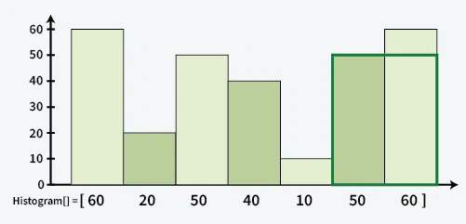
Output:- min(50,60)*width = 100
- Find the next smaller to left and next smaller to right.
- Just as we find the number of element by this formula (j-i+1) but here the mid element from where we are removing NSL and NSR we are considering same element in both so we substract by 1 (NSR – NSL-1) .
- With this we will get the length of our rectangle next step is to get the width.
- Width can be get by the element itself lengths lets how much the array can grow horizontally

int getMaxArea(vector<int> &arr) {
// Your code here
vector<int> NSL;
vector<int> NSR;
solve1(arr,NSL);
solve2(arr,NSR);
int ans = 0;
for(int i=0; i<arr.size(); i++){
int width = NSR[i] - NSL[i] - 1;
ans = max(ans,width*arr[i]);
}
return ans;
}

- Rainwater Trapping

Problem statement:
Given an array arr[] with non-negative integers representing the height of blocks. If the width of each block is 1, compute how much water can be trapped between the blocks during the rainy season.

Input: arr[] = [3, 0, 1, 0, 4, 0 2]
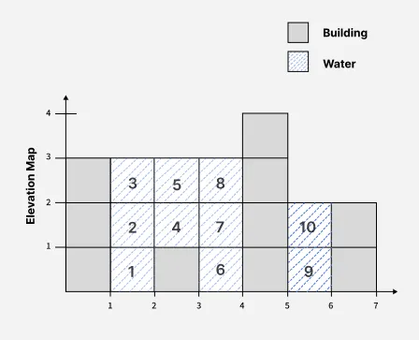
Output: 10
Explanation: Total water trapped = 0 + 3 + 2 + 3 + 0 + 2 + 0 = 10 units.
- Water will bound around the element by the largest element to left and largest to right, at arr[2] (index 2) the water will bound if the there are any element greater in left and in right in this above case arr[0]=3 is greater to 0 and arr[4]=4 is greater so the water will be bound between this element
- The height of the water will depends on the minimum of the both left and right greater element, in this case minimum is 3.
- So the answer will be 3 – arr[curr] = 3 – 1 = 2, so 2 units of water will be stored.
- Our task is to find elements greater in its left and right and the formula above

int trap(vector<int>& height) {
vector<int> maxL;
vector<int> maxR;
solve1(height,maxL);
solve2(height,maxR);
int ans = 0;
for(int i=0; i<height.size(); i++){
height[i] = min(maxL[i],maxR[i]) - height[i];
}
ans = accumulate(height.begin(),height.end(),0);
return ans;
}

Postfix, Prefix & Infix
prefix, infix, and postfix refer to how operators and operands are arranged in an expression.
✅ Operator:
An operator tells what action to perform on the operands.
Common operators:
- + (Addition)
- - (Subtraction)
- * (Multiplication)
- / (Division)
- ^ (Exponentiation or power)
✅ Operand:
An operand is the data (value or variable) on which an operation is performed.
Examples:
- In 3 + 4, the operands are 3 and 4
- In a * b, the operands are a and b

📘 Types of Expressions
- Infix Expression (Human-style)
Structure: operand operator operand
Example: A + B
- Prefix Expression (Polish Notation)
Structure: operator operand operand
Example: + A B
- Postfix Expression (Reverse Polish Notation)
Structure: operand operand operator
Example: A B +

🔢 Operator Precedence (From High to Low):
Operator | Meaning | Associativity
^ | Exponentiation | Right to left
* / | Multiplication / Division | Left to right
+ - | Addition / Subtraction | Left to right

Conversion Infix to Postfix:
a + b * ( c ^ d - e )
Step | Symbol Scanned | Operator Stack | Postfix Expression (Output)
1 | a |  | a
2 | + | + | a
3 | b | + | a b
4 | * | + * | a b
5 | ( | + * ( | a b
6 | c | + * ( | a b c
7 | ^ | + * ( ^ | a b c
8 | d | + * ( ^ | a b c d
9 | - | + * ( - | a b c d ^
10 | e | + * ( - | a b c d ^ e
11 | ) | + * | a b c d ^ e -
12 | End of Expression |  | a b c d ^ e - * +
Steps:
- If operand add to the output
- If operator then if it has more or same priority then present element than push it in stack.
- If operator has less priority then the present element in the stack then will pop stack and add to answer until we get less priority or equal priority element in the stack.
- If get opening bracket just put in stack without checking for priority.
- If get closing bracket add everything of the stack to answer.
- Don’t add bracket to the answer.
Code:
int pri(char op){
if(op == '^') return 3;
else if(op == '*' || op == '/') return 2;
else if (op == '+' || op == '-') return 1;
return -1;
}
int main(){
int ind = 0;
string val = "a+b*(c^d-e)";
stack<int> st;
string ans = "";
while(ind < val.size()){
if(val[ind] >= 'A' && val[ind] <= 'Z' ||
val[ind] >= 'a' && val[ind] <= 'z' ||
val[ind] >= '0' && val[ind] <= '9'){
ans+=val[ind];
}
else if(val[ind] == '(') st.push(val[ind]);
else if(val[ind] == ')'){
while(!st.empty() && st.top() != '('){
ans+= st.top();
st.pop();
}
if(!st.empty()) st.pop();
}

else{
while(!st.empty() && (pri(val[ind]) <= pri(st.top()))){
ans+=st.top();
st.pop();
}
st.push(val[ind]);
}
ind++;
}

while(!st.empty()){
ans += st.top();
st.pop();
}
cout<<ans;
}
-------------------------------------------------------------------------------------------------------------------------------------
Conversion Infix to Prefix
Step-by-step Algorithm:
- Reverse the infix expression.
- Convert to postfix (as if it were the reversed expression).
- Reverse the postfix → this becomes the prefix.
(A + B) * C - D + F
Step 1: Reverse the infix
F + D - C * ( B + A )
Step 2: Convert reversed infix to postfix
Token | Stack | Postfix
F |  | F
+ | + | F
D | + | F D
- | + - | F D
C | + - | F D C
* | + - * | F D C
( | + - * ( | F D C
B | + - * ( | F D C B
+ | + - * ( + | F D C B
A | + - * ( + | F D C B A
) | + - * | F D C B A +
Final postfix = F D C B A + * - +
Step 3: Reverse postfix
Final Prefix= + - * + A B C D F

Conversion Postfix to Infix:
- Don’t need answer variable to store the answer.
- Answer are stored in the stack itself.
- If Operand then Push to stack.
- Operator → Pop 2 operands, create a string:
"(left operand operator right operand)"
Push this back to stack.

Example:
Input: a b c d ^ e - * +

Token | Action | Stack Content
a | Push operand | ["a"]
b | Push operand | ["a", "b"]
c | Push operand | ["a", "b", "c"]
d | Push operand | ["a", "b", "c", "d"]
^ | Pop d, c → push (c ^ d) | ["a", "b", "(c ^ d)"]
e | Push operand | ["a", "b", "(c ^ d)", "e"]
- | Pop e, (c ^ d) →  push ((c ^ d) - e) | ["a", "b", "((c ^ d) - e)"]
* | Pop ((c ^ d) - e), b →  push (b * ((c ^ d) - e)) | ["a", "(b * ((c ^ d) - e))"]
+ | Pop (b * ((c ^ d) - e)), a →  Push (a + (b * ((c ^ d) - e))) | ✅ Final: ["(a + (b * ((c ^ d) - e)))"]

Code:
int main(){
string str = "abcd^e-*+";
stack<string> st;
for(auto& it : str){
if(it >= 'a' && it <='z' || it >= 'A' && it <= 'Z') st.push(string(1,it));
else if(it == '+' || it == '-' || it == '*' || it == '/' || it == '^'){
string a = st.top();
st.pop();
string b = st.top();
st.pop();
string newstr = "("+b+it+a+")";
st.push(newstr);
}
}
cout<<st.top();
}

Conversion Prefix to Infix:
- In this we will iterate from back and also the first element will be first in the wrapping, if top is a and next top is b the it will be (a + b).
- Rest Process is same as postfix to Infix.

Conversion Postfix to Prefix:
- Use a stack of strings.
- Traverse from left to right.
- If operand push to stack.
- If operator then first pop top1 and second pop top2 will become => operator+top2+top1
- Last will contain the answer

Conversion Prefix to Postfix:
- Use a stack of string.
- Traverse from right to left.
- If operand push to stack.
- If operator then first pop top1 and second pop top2 will become => top1+top2+operator.

Singly Link List
- Array to linklist
class Node{
public:
int data;
Node* next;
Node(int data1){
data = data1;
next = NULL;
}
};

int main(){
vector<int> arr = {1,2,3,4,5};
Node* head = new Node(arr[0]);
Node*mover = head;
for(int i=1; i<arr.size(); i++){
Node* temp = new Node(arr[i]);
mover->next = temp;
mover = temp;
}

while(head != NULL){
cout<<head->data<<" ";
head = head->next;
}
}
- Deletion in Link-List
  - Delete from head
- To delete from we just have to move the head to next
Node* deletehead(Node* head){
if(head == NULL) return NULL;
Node* temp = head;
head = head->next;
delete temp;
return head;
}
  - Delete From Tail
Node* deleteTail(Node* head){
if(head == NULL || head->next == NULL) return NULL;
Node* tail = head;
while(tail->next->next != NULL){
tail = tail->next;
}
Node* temp = tail->next;
tail->next = NULL;
delete temp;
return head;
}

  - Delete at K position
Node* deleteK(Node* head, int k){
if(head == NULL || head->next == NULL) return NULL;
int cnt = 1;
Node* temp = head;
if(k == 1){
Node* temp = head;
head = head->next;
delete temp;
return head;
}
while(temp != NULL && cnt != k-1){
temp=temp->next;
cnt++;
}
if (temp == NULL || temp->next == NULL) return head;
Node* deln = temp->next;
temp->next=temp->next->next;
delete deln;
return head;
}
  - Delete by Given Value
Node* deleteValue(Node* head, int k){
if(head == NULL || head->next == NULL) return NULL;
if(k == head->data){
Node* temp = head;
head = head->next;
delete temp;
return head;
}
Node* temp = head;
Node* prev = head;
while(temp != NULL && temp->data != k){
prev = temp;
temp=temp->next;
}
if (temp == NULL) return head;
Node* deln = prev->next;
prev->next=prev->next->next;
delete deln;
return head;
}

- Insertion in Link-List
  - Insert At Head
Node* insertHead(Node* head, int val){
Node* temp = new Node(val);
temp->next = head;
return temp;
}

  - Insert At Tail
Node* insertTail(Node* head, int val){
Node* temp = head;
while(temp->next != NULL){
temp = temp->next;
}
temp->next = new Node(val);
return head;
}
  - Insert At k position
Node* insertK(Node* head, int val, int pos){
if(head == NULL) return head;
if(pos == 1){
Node* temp = new Node(val);
temp->next = head;
return temp;
}
int k = 1;
Node* temp = head;
while(temp != NULL && k != pos-1){
temp=temp->next;
k++;
}
if(temp == NULL) return head;
Node* newNode = new Node(val);
newNode->next = temp->next;
temp->next = newNode;
return head;
}
  - Insert Before Value
Node* insertBefore(Node* head, int val, int pos){
if(head == NULL) return head;
if(pos == head->data){
Node* temp = new Node(val);
temp->next = head;
return temp;
}
Node* temp = head;
while(temp != NULL && temp->next->data != pos){
temp=temp->next;
}
if(temp == NULL) return head;
Node* newNode = new Node(val);
newNode->next = temp->next;
temp->next = newNode;
return head;
}

Questions on singly Link-List
- Tortoise and Hare (slow and fast pointer) approach (Floyd’s Cycle Detection).
- To find the middle node of a singly linked list, you can use the Tortoise and Hare (slow and fast pointer) approach efficiently.
Concept:
- Slow pointer (tortoise) moves one step at a time.
- Fast pointer (hare) moves two steps at a time.
- When fast reaches the end, slow will be at the middle.
ListNode* middleNode(ListNode* head) {
if(head == NULL) return head;
ListNode* slow = head;
ListNode* fast = head;
while(fast != NULL && fast->next != NULL){
slow = slow->next;
fast = fast->next->next;
}
return slow;
}

- To find the loop in a link list.
Concept:
- Slow pointer (tortoise) moves one step at a time.
- Fast pointer (hare) moves two steps at a time.
- If there is a cycle, the fast pointer will eventually meet the slow pointer inside the cycle.
- If there is no cycle, the fast pointer will reach the end (NULL) without meeting the slow pointer.
bool hasCycle(ListNode *head) {
ListNode* slow = head;
ListNode* fast = head;
while(fast != NULL && fast->next != NULL){
slow = slow->next;
fast = fast->next->next;
if(slow == fast) return true;
}
return false;
}

- To Find the starting point of the loop
Concept:
- Slow pointer (tortoise) moves one step at a time.
- Fast pointer (hare) moves two steps at a time.
- If there is a cycle, both pointers will meet at some point inside the cycle.
- After meeting, reset the slow pointer to the head of the linked list.
- Now move both slow and fast pointers one step at a time.
- The point where they meet again will be the starting point of the cycle.

Why it works?
- x = distance from head to start of loop
- y = distance from loop start to meeting point
- L = total length of the loop
Now let's say:
- Slow moves 1 step each time → distance = x + y
- Fast moves 2 steps → distance = x + y + n·L
(n is how many times fast goes around the loop)
We know,
Fast = 2 × Slow
=> x + y + nL = 2(x + y)
x + y + nL = 2x + 2y
=> nL = x + y
=> x = nL – y
Now observe:
- x = (loop length - y)
→ If you start at the meeting point and go L - y steps, you reach the start of the loop.
- So, if one pointer is at head (x away from loop start)
and the other at meeting point (L - y away from loop start),
both will reach start of loop in the same number of steps.

ListNode *detectCycle(ListNode *head) {
ListNode* slow = head;
ListNode* fast = head;
while(fast != NULL && fast->next != NULL){
slow = slow->next;
fast = fast->next->next;
if(slow == fast){
slow = head;
while(slow != fast){
slow = slow->next;
fast = fast->next;
}
return slow;
}
}
return NULL;
}

- Reverse Link-List iterative
ListNode* reverseList(ListNode* head) {
ListNode* temp = head;
ListNode* prev = NULL;
while(temp != NULL){
ListNode* next = temp->next; // 1. Store next node
temp->next = prev; // 2. Reverse current link
prev = temp; // 3. Move prev forward
temp=next; // 4. Move temp forward
}
return prev;
}
Recursive
void reverse(ListNode*& head){
if(head == NULL || head->next == NULL) return;
ListNode* rest=head->next;
reverse(rest);
head->next->next = head;
head->next = NULL;
head = rest;
}

- Check for Palindrome
bool isPalindrome(ListNode* head) {
ListNode* slow = head;
ListNode* fast = head;

// Step 1: Find the middle of the list using slow and fast pointers
while(fast != NULL && fast->next != NULL){
slow = slow->next;
fast = fast->next->next;
}

// Step 2: Reverse the second half of the list
ListNode* secondhalf = reverse(slow);

// Step 3: Compare the first half and reversed second half
ListNode* firsthalf = head;
while(secondhalf != NULL){
if(secondhalf->val != firsthalf->val) return false;
secondhalf = secondhalf->next;
firsthalf = firsthalf->next;
}
return true;
}

- Sort Link-List
For Sorting of linkList we will be using merge Sort
ListNode* getMid(ListNode* head){
ListNode* slow = head;
ListNode* fast = head->next;
while(fast != NULL && fast->next != NULL){
slow = slow->next;
fast = fast->next->next;
}
return slow;
}
ListNode* merge(ListNode* left, ListNode* right){
ListNode* dummy = new ListNode(-1);
ListNode* temp = dummy;
while(left != NULL && right != NULL){
if(left->val < right->val){
temp->next = left;
temp = left;
left = left->next;
}
else{
temp->next = right;
temp = right;
right = right->next;
}
}
if(left) temp->next = left;
else temp->next = right;
return dummy->next;
}
ListNode* sortList(ListNode* head) {
// Base Case
if(head == NULL || head->next == NULL) return head;
ListNode* mid = getMid(head);
ListNode* left = head;
ListNode* right = mid->next;
mid->next = NULL;
left = sortList(left);
right = sortList(right);
ListNode* ans = merge(left,right);
return ans;
}
Time Complexity:
- The list is divided into two halves recursively — log n levels of recursion.
- At each level, we merge all nodes — total n comparisons per level.
- So, total time: O(n logn)
Space Complexity:
- Although no new linked lists are created except the dummy node, the recursive calls on sortList consume stack space.
- The depth of the recursion is log n, where n is the number of nodes.
- No extra data structures are used, so: O(log n).

- Flatten the Link-List
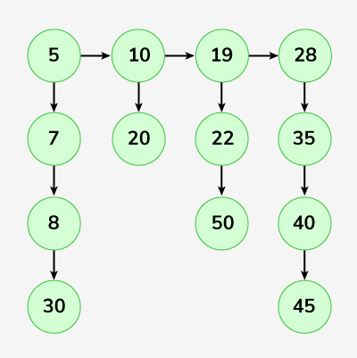
Output: 5-> 7-> 8-> 10 -> 19-> 20-> 22-> 28-> 30-> 35-> 40-> 45-> 50.
Code:
Node* flatten(Node* root) {
// Base case: if root is NULL or there's only one list
if (root == NULL || root->next == NULL) return root;

// Recursively flatten the rest of the list
Node* mergeHead = flatten(root->next);

// Merge current list with already flattened list
return merge(mergeHead, root);
}
Node* merge(Node* l1, Node* l2) {
// Create a dummy node to simplify the merging process
Node* dummy = new Node(-1);
Node* ans = dummy;
// Traverse both lists and link the smaller node to the result list
while (l1 != NULL && l2 != NULL) {
if (l1->data < l2->data) {
ans->bottom = l1; // attach l1 to the result
ans = l1; // move the pointer forward
l1 = l1->bottom; // move l1 to next bottom node
} else {
ans->bottom = l2; // attach l2 to the result
ans = l2;
l2 = l2->bottom;
}
ans->next = NULL; // make sure 'next' pointer is null
}
// Attach the remaining part of l1 or l2
if (l1) ans->bottom = l1;
else ans->bottom = l2;
// Return the merged list (starting from dummy->bottom)
return dummy->bottom;
}

- Copy List with Random Pointer
- With Map
Node* temp = head;
unordered_map<Node* , Node*> mpp;
while(temp){
Node* newNode = new Node(temp->val);
mpp[temp] = newNode;
temp = temp->next;
}
temp = head;
while(temp){
Node* copy = mpp[temp];
copy->next = mpp[temp->next];
copy->random = mpp[temp->random];
temp = temp->next;
}
return mpp[head];
- Without Map
Node* temp = head;
// step 1: create copy of them between them
while(temp){
Node* copy = new Node(temp->val);
copy->next = temp->next;
temp->next = copy;
temp = temp->next->next;
}
//step 2 : connecting random number
temp = head;
while(temp){
if(temp->random) temp->next->random = temp->random->next;
else temp->next->random = NULL;
temp = temp->next->next;
}
// step 3: connecting the new duplicate node(extracting)
temp = head;
Node* dummy = new Node(-1);
Node* res = dummy;
while(temp){
res->next = temp->next;
temp->next = temp->next->next;
res = res->next;
temp = temp->next;
}
return dummy->next;
}

Doubly Link List
- Array to Doubly Link-List
class Node{
public:
int data;
Node* next;
Node* back;
Node(int data1, Node* next1, Node* back1){
data = data1;
next = next1;
back = back1;
}
Node(int data1){
data = data1;
next = NULL;
back = NULL;
}
};

int main(){
vector<int> arr = {1,2,3,4,5};
Node* head = new Node(arr[0]);
Node* prev = head;
for(int i=1; i<arr.size(); i++){
//Node* curr = new Node(arr[i],NULL,prev);
Node* curr = new Node(arr[i]);
prev->next = curr;
curr->back = prev;
prev = curr;
}
}

- Deletion in Doubly Link-List
// Delete Head
Node* deleteHead(Node* head){
if(head == NULL || head->next == NULL) return NULL;
Node* prev = head;
head= head->next;
head->back = NULL;
prev->next = NULL;
delete prev;
return head;
}

//delete Tail
Node* deleteTail(Node* head){
if(head == NULL || head->next == NULL) return NULL;
Node* temp = head;
while(temp->next->next != NULL){
temp = temp->next;
}
Node* next = temp->next;
temp->next = NULL;
delete next;
return head;
}

//Delete at k position
Node* deleteK(Node* head, int k){
int cnt = 1;
if(head == NULL) return NULL;
if(k == 1){
Node* prev = head;
head = head->next;
head->back = NULL;
prev->next = NULL;
delete prev;
return head;
}
Node* temp = head;
while(k-1 != cnt){
temp = temp->next;
cnt++;
}
if(temp == NULL || temp->next == NULL) return head;
Node* next = temp->next;
temp->next = temp->next->next;
next->back = NULL;
next->next = NULL;
delete next;
return head;
}

- Insertion in doubly Link-List
Insert At head
Node* insertHead(Node* head, int val){
Node* temp = new Node(val);
head->back = temp;
temp->next = head;
return temp;
}

// Insert At Tail
Node* insertTail(Node* head, int val){
Node* temp = new Node(val);
Node* tail = head;
while(tail->next != NULL) tail = tail->next;
tail->next = temp;
temp->back = tail;
return head;
}
//Insert At k Position
Node* insertK(Node* head, int val, int k){
if(k == 1){
Node* temp = new Node(val);
temp->next = head;
head->back = temp;
return temp;
}
if(head == NULL) return head;
int curr = 1;
Node* temp = head;
while(temp != NULL){
curr++;
if(curr == k) break;
temp = temp->next;
}
if(temp == NULL ) return head;
if(temp->next == NULL){
Node* newNode = new Node(val);// temp is at tail and k is just after tail
temp->next = newNode;
newNode->back = temp;
return head;
}
Node* newNode = new Node(val);
Node* prev = temp->next;
temp->next = newNode;
newNode->back = temp;
newNode->next = prev;
prev->back = newNode;

return head;
}

- Reverse Double link list
DLLNode* reverseDLL(DLLNode* head) {
DLLNode* prev = NULL;
DLLNode* temp = head;
while(temp != NULL){
DLLNode* curr = temp->next;
temp->next = prev;
temp->prev = curr;
prev = temp;
temp = curr;
}
return prev;
}

Trees
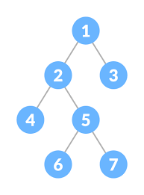
Types of binary trees
- Full Binary Tree
- A binary tree in which every node has either 0 or 2 children.
- No node has only one child.

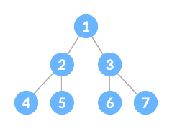
- Perfect Binary Tree
- All internal nodes have exactly 2 children
- All leaf nodes are at the same level.
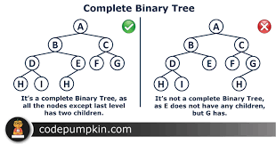
- Complete Binary Tree
- All levels are filled, except possibly the last level
- The last level is filled from left to right.

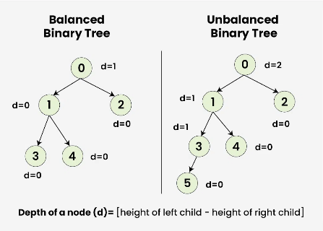
- Balanced Binary Tree
- A binary tree where the height difference between the left and right subtree of every node is at most 1.
- Used in AVL Trees, Red-Black Trees.

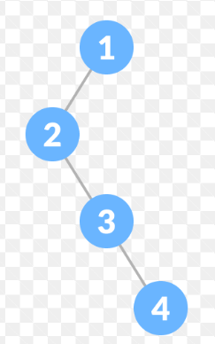
- Degenerate (or Skewed) Tree
- A tree where each parent node has only one child.
- Acts like a linked list.

Trees Representation:
#include<bits/stdc++.h>
using namespace std;

class Node{
public:
int data;
Node* left;
Node* right;

Node(int data){
this->data = data;
left = NULL;
right = NULL;
}
};

int main(){
// Construct the tree:
// 1
// / \
// 2 3
// / \ / \
// 4 5 6 7
Node* root = new Node(1);
root->left = new Node(2);
root->right = new Node(3);
root->left->left = new Node(4);
root->left->right = new Node(5);
root->right->left = new Node(6);
root->right->right = new Node(7);
}

DFS (Depth First Search)
  - Depth First Search is a tree/graph traversal algorithm that explores as far down a path as possible before backtracking.
  - Traversal Types in DFS
    - Preorder: Root → Left → Right.
    - Inorder: Left → Root → Right.
    - Postorder: Left → Right → Root.

- Inorder Traversal (Left → Root → Right) Recursive
void inorder(Node* root){
if(!root) return;
inorder(root->left);
cout<<root->data<<" ";
inorder(root->right);
}
Inorder Traversal (Left → Root → Right) Using Stack
void inorderSt(Node* root){
stack<Node*> st;
Node* curr = root;
while(curr || !st.empty()){
while(curr){
st.push(curr);
curr = curr->left;
}
curr = st.top();
st.pop();
cout<<curr->data<<" ";
curr = curr->right;
}
}

- Preorder Traversal (Root → Left → Right) Recursive
void preorder(Node* root){
if(!root) return;
cout<<root->data<<" ";
preorder(root->left);
preorder(root->right);
}
Preorder Traversal (Root → Left → Right) Using Stack
void preorderSt(Node* root){
stack<Node*> st;
st.push(root);
while(!st.empty()){
Node* curr = st.top();
st.pop();
cout<<curr->data<<" ";
if(curr->right) st.push(curr->right);
if(curr->left) st.push(curr->left);
}
}

- Postorder Traversal (Left → Right → Root) Recursive
void postorder(Node* root){
if(!root) return;
postorder(root->left);
postorder(root->right);
cout<<root->data<<" ";
}

Postorder Traversal (Left → Right → Root) Recursive
void postorderSt(Node* root){
stack<Node*> st1;
stack<Node*> st2;
st1.push(root);
while(!st1.empty()){
Node* node = st1.top();
st1.pop();
st2.push(node);
if(node->left) st1.push(node->left);
if(node->right) st1.push(node->right);
}
while(!st2.empty()){
Node* node = st2.top();
cout<<node->data<<" ";
st2.pop();
}
}

- Level Order Traversal
void levelOrder(Node* root){
queue<Node*> q;
q.push(root);

while(!q.empty()){
Node* curr = q.front();
q.pop();
cout<<curr->data<<" ";
if(curr->left) q.push(curr->left);
if(curr->right) q.push(curr->right);
}
}

Question:
      - Height of binary tree
Given the root of a binary tree, return its maximum depth. A binary tree's maximum depth is the number of nodes along the longest path from the root node down to the farthest leaf node.
if(!root) return 0;

return 1 + max(maxDepth(root->left), maxDepth(root->right

if(!root) return 0;
queue<TreeNode*> q;
q.push(root);
int ans = 0;
while(!q.empty()){
int size = q.size();
for(int i=0; i<size; i++){
TreeNode* curr = q.front();
q.pop();
if(curr->left) q.push(curr->left);
if(curr->right) q.push(curr->right);
}
ans++;
}
return ans;

      - Check for Balanced Binary Tree
A balanced binary tree is a tree where the difference in height between the left and right subtree of every node is at most 1.
get height of subtrees.
At each node:
- Calculate left Height and right Height.
- If abs(left Height - right Height) > 1, it's unbalanced.
Return -1 if unbalanced — and propagate up.
Brute Force:
bool isBalanced(TreeNode* root) {
if(!root) return 1;
int left = height(root->left);
int right = height(root->right);
cout<<abs(left-right)<<" ";
if(abs(left-right) > 1) return 0;
bool left1 = isBalanced(root->left);
bool right1 = isBalanced(root->right);
if(!left1 || !right1) return false;
return true;
}
The Optimal Solution
The solution to both of these problems is to combine the height calculation and the balance check into a single, efficient (O(N)) recursive pass. This is the standard "bottom-up" approach for this problem.

The key is to have a helper function that returns two pieces of information at once: the height of a subtree, and whether it's balanced. A clever way to do this is to return the height on success, and a special value like -1 to signal that an imbalance was found.

Here is that efficient and correct code one more time as a reference. This is the standard, accepted solution for this classic problem.

int height(TreeNode* root){
if(!root) return 0;
int left = height(root->left);
int right = height(root->right);
if(abs(left-right) > 1) return -1;
if(left == -1 || right == -1) return -1;
return 1 + max(left,right);
}

bool isBalanced(TreeNode* root) {
if(height(root) != -1) return true;
return false;
}

      - Diameter of a tree
By removing the height of a tree we can also calculate by adding the left and right part of the tree at every point
int solve(TreeNode* root, int& maxi){
if(!root) return 0;
int left = solve(root->left,maxi);
int right = solve(root->right,maxi);
maxi = max(maxi,left+right);
return 1 + max(left,right);
}
Maxi is the answer

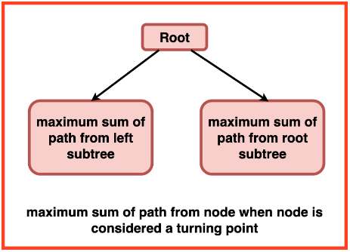
      - Maximum Sum Path in Binary Tree
We can calculate the maximum sum from root to left and right and in between we will keep updating our maxi function
If the number comes to be negative then have to take 0 because adding negative to the val will decrease the sum path soo instead take 0

int solve(TreeNode* root, int& maxi){
if(!root) return 0;
int left = max(0,solve(root->left,maxi));
int right = max(0,solve(root->right,maxi));
maxi = max(maxi,root->val+left+right);
return root->val+max(left,right);
}

int maxPathSum(TreeNode* root) {
int maxi = INT_MIN;
solve(root, maxi);
return maxi;
}

      - Zig Zag Traversal of Binary Tree
It is same as level order traversal but in this we can use a bool to check weather to travel from left to right or right to left.
vector<vector<int>> zigzagLevelOrder(TreeNode* root) {
if(!root) return {};
vector<vector<int>> ans;
queue<TreeNode*> q;
q.push(root);
bool flag = false;
while(!q.empty()){
int size = q.size();
vector<int> row(size);
for(int i=0; i<size; i++){
TreeNode* node = q.front();
q.pop();
int index;
if(flag == 0) index = i;
else index = size - 1 - i;
row[index] = node->val;
if(node->left) q.push(node->left);
if(node->right) q.push(node->right);
}
flag = !flag;
ans.push_back(row);
}
return ans;
}

      - Boundary Traversal of Binary Tree
A vector is declare to return the answer in that vector we add the root element only if it is not the root element because in root traversal every element is traverse soo the repetition will occur of the root element.
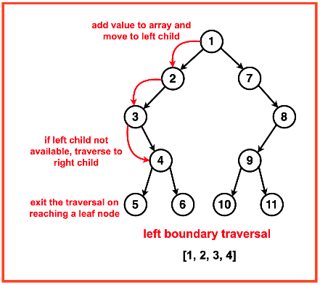
Step 1: Initialise a recursive function `addLeftBoundary` and a vector to store the left traversal.
- Start from the root of the tree.
- Traverse down the left side of the tree until we reach a leaf node. For each non-leaf node, add its value to the result list.
- Traverse to its left child. If unavailable, call the recursion function to its right child.

void leftBoundry(Node* root, vector<int>& ans){
Node* curr = root;
while(curr){
if(!leaf(curr)) ans.push_back(curr->data);
if(curr->left) curr = curr->left;
else curr= curr->right;
}
}

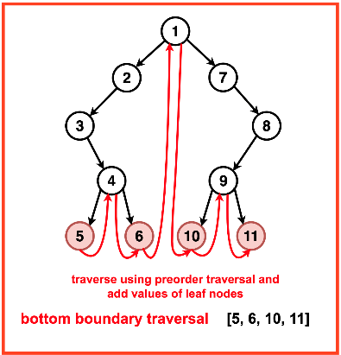
Step 2: Implement a recursive function `rootLeave` and a vector to store the bottom traversal.
- If the current node is a leaf, add its value to the result list.
- Recursively travel to the current nodes left and right subtrees in a preorder fashion.

void rootLeave(Node* root, vector<int>& ans){
if(leaf(root)){
ans.push_back(root->data);
}
if(root->left) rootLeave(root->left,ans);
if(root->right) rootLeave(root->right,ans);
}
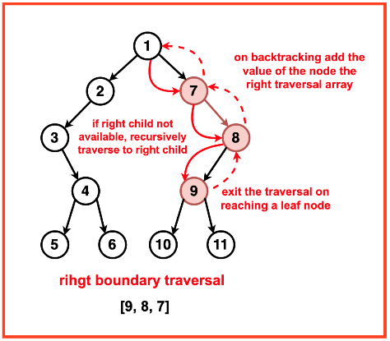
Step 3: Implement a recursive function `addRightBoundary` and a vector to store the right traversal.
- Start from the root of the tree.
- Traverse to the right most side of the tree until we reach a leaf node.
- For each non-leaf node, call the recursive function to its right child; if unavailable, call to its left child.
- While the recursion backtracks, add the current node’s value to the result list.
void rightBoundry(Node* root, vector<int>& ans){
stack<int> st;
while(root){
if(!leaf(root)) st.push(root->data);
if(root->right) root = root->right;
else root = root->left;
}

while(!st.empty()){
ans.push_back(st.top());
st.pop();
}
}

      - Line Concept in Trees
What is a "line" in tree problems?
- Imagine drawing a vertical line through each node of the tree.
- This line is identified by a Horizontal Distance (HD) from the root:
  - Root’s HD = 0
  - Move left → HD decreases by 1
  - Move right → HD increases by 1
- All nodes with the same HD lie on the same vertical line.

Use in Problems
- Top View → Take the first node seen in each line from top to bottom.
- Bottom View → Take the last node seen in each line from top to bottom.
- Vertical Traversal → List all nodes in a line from top to bottom.

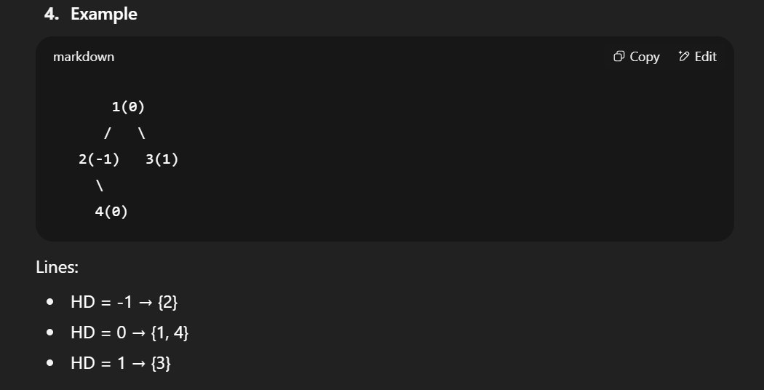

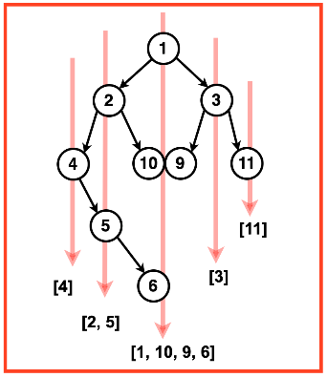
      - Vertical Order Traversal of Binary Tree
Given a Binary Tree, return the Vertical Order Traversal of it starting from the Leftmost level to the Rightmost level. If there are multiple nodes passing through a vertical line, then they should be printed as they appear in level order traversal of the tree.

Approach: Vertical Order Traversal using BFS
- Assign Coordinates
  - Each node has (x, y) →
    - x = vertical column (left → negative, right → positive)
    - y = level/depth (root = 0, deeper nodes = higher y)
- Use a Map for Storing Nodes
  - map<int, map<int, multiset<int>>> mp;
    - Outer x → groups nodes by vertical column.
    - Inner y → groups nodes by level in that column.
    - multiset → keeps values sorted when multiple nodes share same (x, y).
- BFS Traversal
  - Use queue storing (node, x, y).
  - Start with (root, 0, 0).
  - For each node:
    - Insert into mp[x][y].
    - Left child → (x-1, y+1)
    - Right child → (x+1, y+1)
- Build Final Answer
  - Traverse mp in order of x (left → right).
  - For each column, collect values from all y in order (top → bottom).
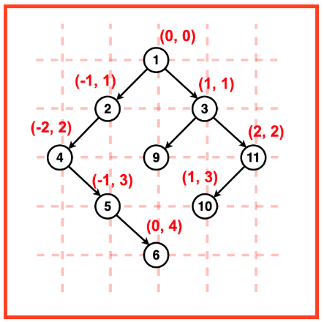
  - Append to result vector.
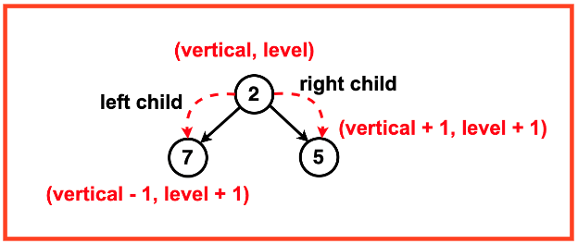

vector<vector<int>> verticalTraversal(TreeNode* root) {
// Map structure: x -> (y -> multiset of node values)
// x = vertical column, y = level, multiset keeps values sorted
map<int,map<int,multiset<int>>> nodes;

// Queue for BFS: stores (node, (x, y)) → x = column, y = level
queue<pair<TreeNode*, pair<int,int>>> pq;

pq.push({root,{0,0}}); // Start with root at (x=0, y=0)

// BFS traversal
while(!pq.empty()){
auto p = pq.front();
pq.pop();
TreeNode* node = p.first;
int x = p.second.first; // current vertical column
int y = p.second.second; // current level

// Insert node's value into map at (x, y)
nodes[x][y].insert(node->val);

// Go to left child: column - 1, level + 1
if(node->left) pq.push({node->left,{x-1,y+1}});

// Go to right child: column + 1, level + 1
if(node->right) pq.push({node->right,{x+1,y+1}});
}

// Prepare final result
vector<vector<int>> ans;

// Traverse map in order: columns from left to right
for(auto layer1 : nodes){
vector<int> col; // current column

// For each level in this column (top to bottom)
for(auto layer2 : layer1.second){

// Append all node values from multiset to col
col.insert(col.end(),layer2.second.begin(),layer2.second.end());
}
// Add this column to final answer
ans.push_back(col);
}
return ans;
}

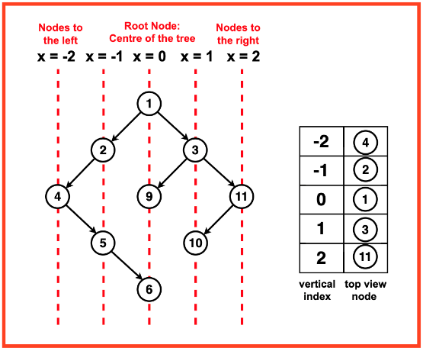
      - Top View of Binary Tree
To imagine the Binary Tree from above, we visualise vertical lines passing through the tree.
Each vertical line represents a unique vertical position.
As we move to the right, the vertical index increases.
As we move to the left, the vertical index decreases.

Algorithm:
Step 1: Create a vector `ans` to store the result. Check if the tree is empty. If it is, return an empty vector.
Step 2: Create a map to store the top view of nodes based on their vertical positions. The key of this map is the vertical index and the value is the node’s data.
Step 3: BFS Traversal

vector<int> topView(Node *root) {
// If the tree is empty, return an empty vector
if (!root) return {};

vector<int> ans; // This will store the final top view nodes
queue<pair<Node*, int>> q; // Queue to store nodes with their horizontal distance (HD)
map<int, int> mpp; // Map to store the first node data for each HD (sorted by HD automatically)

// Push root node with HD = 0 into the queue
q.push({root, 0});

// BFS traversal
while (!q.empty()) {
auto it = q.front(); // Get the front element
q.pop();

Node* node = it.first; // Current node
int line = it.second; // Horizontal distance (HD) of the current node

// If this HD is not present in map, add it (first node at this HD will be visible in top view)
if (mpp.find(line) == mpp.end())
mpp[line] = node->data;

// Push the left child with HD - 1
if (node->left) q.push({node->left, line - 1});

// Push the right child with HD + 1
if (node->right) q.push({node->right, line + 1});
}
// Extract node values from the map in sorted order of HD
for(auto it : mpp) ans.push_back (it.second);
return ans;

      - Bottom View
Same as the above problem using line concept in trees just difference we have keep updating the map values rest everything is same.
vector<int> bottomView(Node *root) {
// Function to return the bottom view of a binary tree
if(!root) return {}; // If the tree is empty, return an empty vector

vector<int> ans; // To store the final bottom view
queue<pair<Node*,int>> q; // Queue to store nodes along with their horizontal line numbers
map<int,int> mpp; // Map to store the most recent node data for each horizontal line

q.push({root,0}); // Start BFS traversal from root at line 0

while(!q.empty()){
auto it = q.front(); // Get the front element from the queue
q.pop();
Node* node = it.first; // Current node
int line = it.second; // Current horizontal line number

mpp[line] = node->data; // Update the value for the current line (last seen node will be stored)

// Push the left child to queue with line - 1
if(node->left) q.push({node->left,line-1});
// Push the right child to queue with line + 1
if(node->right) q.push({node->right,line+1});
}

// Extract values from map in order of horizontal line numbers
for(auto it: mpp){
ans.push_back(it.second);
}
return ans; // Return the bottom view
}

      - Binary Tree Right Side View
Same as the above problem only difference is we have see the right values so a simple level order traversal from line = 0 to line = n, ans keep on changing map the last map value will be the ans.
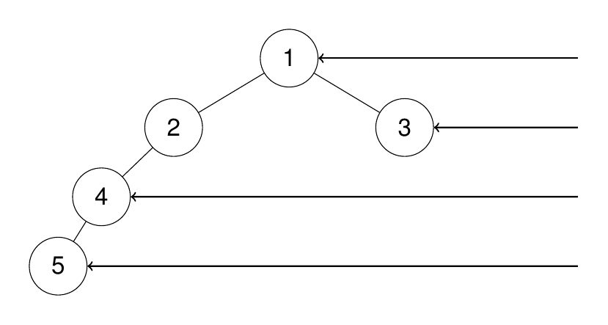

vector<int> rightSideView(TreeNode* root) {
if(!root) return {};
vector<int> ans;
queue<pair<TreeNode*, int>> q;
map<int,int> mpp;
q.push({root,0});

while(!q.empty()){
auto it = q.front();
q.pop();
TreeNode* node = it.first;
int line = it.second;
mpp[line] = node->val;

if(node->left) q.push({node->left, line+1});
if(node->right) q.push({node->right,line+1});
}

for(auto it : mpp){
ans.push_back(it.second);
}
return ans;
}

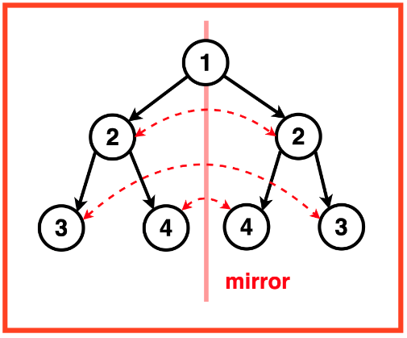
      - Symmetric Tree
For a binary tree to be symmetric:
- The root node and its two subtrees (left and right) must have the same value.
- The left subtree of the root should be a mirror image of the right subtree.
- This mirroring should be consistent throughout the entire tree, not just at the root level.

bool solve(TreeNode* root1, TreeNode* root2){
// If either node is NULL, both must be NULL for symmetry
if(root1 == NULL || root2 == NULL) return root1==root2;

// If the values of the current nodes don't match, it's not symmetric
if(root1->val != root2->val) return false;

// Check:
// 1. Left subtree of root1 with right subtree of root2
// 2. Right subtree of root1 with left subtree of root2
return (solve(root1->left,root2->right) && solve(root1->right,root2->left));
}

bool isSymmetric(TreeNode* root) {
if(!root) return true;
return solve(root->left,root->right);
}

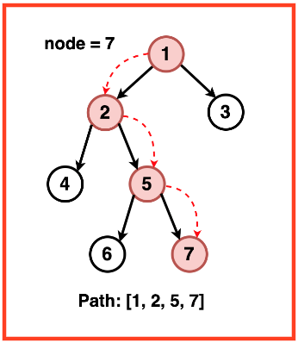
Trees HARD
  - Path to Given Node
Given a Binary Tree A containing N nodes. You need to find the path from Root to a given node B.
- No two nodes in the tree have the same data value.
- It is assured that the given node is present and a path always exists.

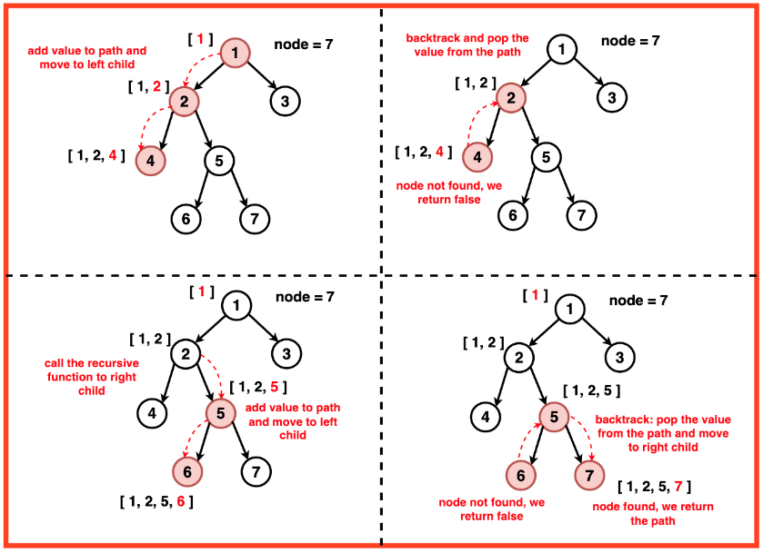
To find the path from the root to the given node in the tree we use a Depth-First Traversal. We initialise a vector to store the current path and recursively travel to each node in the tree. At each step, we check if the current node is null, if it is we return false and if the data value of the current node is equal to the given node, we return true signifying the end of the traversal search.
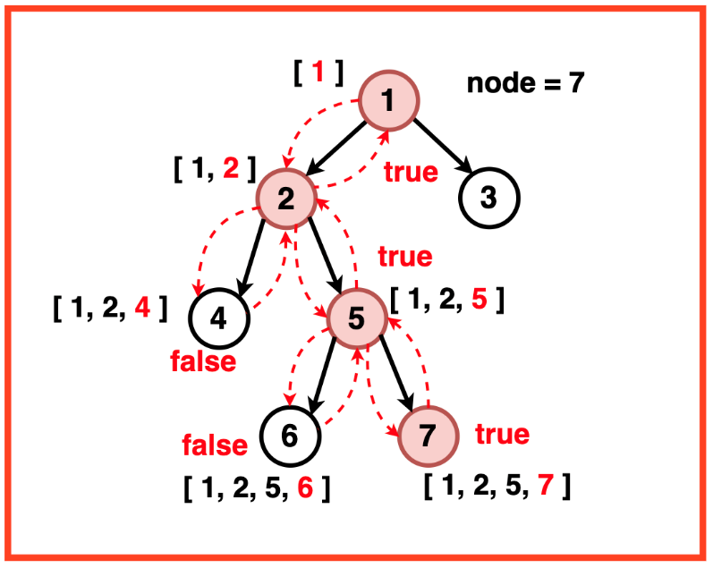
bool solve1(TreeNode* root, int x, vector<int>& arr){
if(!root) return false;
arr.push_back(root->val);

if(root->val == x) return true;

if(solve1(root->left,x,arr) || solve1(root->right,x,arr)) return true;
arr.pop_back();
return false;
}

vector<int> Solution::solve(TreeNode* root, int val) {
vector<int> arr;
if(!root) return {};
solve1(root,val,arr);
return arr;
}

  - Lowest Common Ancestor of a Binary Tree
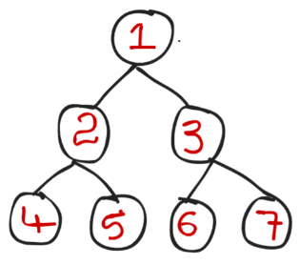
Given a binary tree, find the lowest common ancestor (LCA) of two given nodes in the tree.
Example: x = 4 , y = 5
Ans: 2

Brute: we can find the path of both 4 and 5 from root using the previous method and keep comparing the path if both equal then store in ans and move forward and if not return the stored value

Path of 4 = [1->2->4]
Path of 5 = [1->2->5]
So 2 is last common between them return 2.
// paths function code is above

TreeNode* lowestCommonAncestor(TreeNode* root, TreeNode* p, TreeNode* q) {
vector<TreeNode*>path1;
vector<TreeNode*>path2;

// Find path from root to node p, store in path1
path(root,p->val,path1);

// Find path from root to node q, store in path2
path(root,q->val,path2);

// Variable to store the Lowest Common Ancestor (LCA)
TreeNode* ans = NULL;
int mini = min(path1.size(),path2.size());

// Iterate over both paths simultaneously
for(int i=0; i<mini; i++){
if(path1[i] == path2[i]) ans = path1[i];
else break;
}
return ans;
}

Optimal Solution:
    - If the current node is NULL, or it matches p or q, return it.
    - Recursively search in left and right subtrees.
    - If one side returns NULL, return the other side (LCA is in that side).
    - If both sides return non-NULL, it means p is in one subtree and q is in the other — so the current node is the LCA.

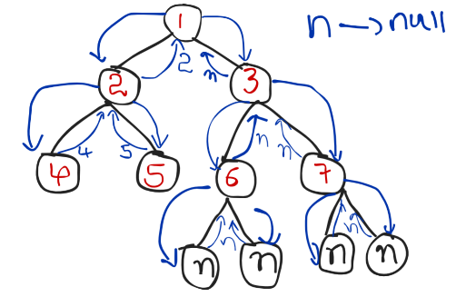
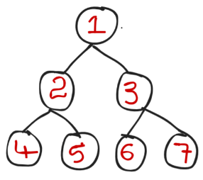
Example: LCA OF 4,5
- It will start From left side till the bottom and it got 4 so it will return 4 to root 2.
- Now from root 2 it goes to right side which root 5 and hence 5 also matches it will return 5.
- Now both left and right are not NULL so root will be return hence 2 will be return to 1.
- Now From root 1 left right return 2 and now reccursion will go to its right side root 3.
- Again from root 3 towards its left side root 6 and hence both left and right of node 6 is NULL so it will return NULL.
- Similary 7 will also return NULL and right of node 1 return NULL.
- As right return NULL ans will be at root left which return 2 so ans is 2.

Code:
TreeNode* lowestCommonAncestor(TreeNode* root, TreeNode* p, TreeNode* q) {
// BASE CASE:
// If current node is NULL, or matches p or q,
// return it immediately
if(root == NULL || p == root || q == root){
return root;
}

// Recursively search for p and q in the left subtree
TreeNode* left = lowestCommonAncestor(root->left,p,q);

// Recursively search for p and q in the right subtree
TreeNode* right = lowestCommonAncestor(root->right,p,q);

// If left is NULL, it means both p and q are in the right subtree
if(left == NULL) return right;

// If right is NULL, it means both p and q are in the left subtree
else if(right == NULL) return left;

// If both left and right are non-NULL, p is in one subtree and q is in the other,
// so the current node is their Lowest Common Ancestor
else return root;
}

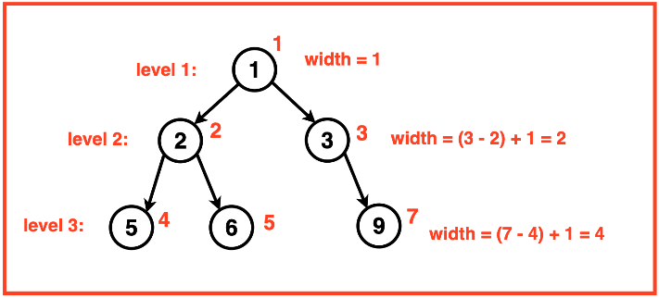
  - Maximum Width of Binary Tree
Given a Binary Tree, return its maximum width. The maximum width of a Binary Tree is the maximum diameter among all its levels. The width or diameter of a level is the number of nodes between the leftmost and rightmost nodes.

Approach:-
To determine the maximum width of a tree, an effective strategy would be to assign and identify indexes for the leftmost and rightmost nodes at each level. Using these indexes, we can calculate the width for each level by subtracting the index of the leftmost node from that of the rightmost node.
If we start root from 0
  - It’s left will be 2*root+1 = 2*0+1 = 1
  - It’s right will be 2*root+2 = 2*0+2 = 2, and so on…
Basic BFS and calculate width at each level and keep updating the answer
Code:
int widthOfBinaryTree(TreeNode* root) {
queue<pair<TreeNode*,int>> q;
q.push({root,0});
int ans = 0;
while(!q.empty()){
int size = q.size();

// Take the first and last indices at this level
int x = q.front().second; // leftmost node index
int y = q.back().second; // rightmost node index

// Width of this level = rightmost - leftmost + 1
ans = max(ans,y-x+1);

// Process all nodes in the current level
for(int i=0;i<size; i++){
TreeNode* node = q.front().first;
int cnt = q.front().second;
q.pop();
if(node->left) q.push({node->left,2*cnt+1});
if(node->right) q.push({node->right,2*cnt+2});
}
}
return ans;
}

This code fails because node indices grow too large, and storing them in int causes overflow.

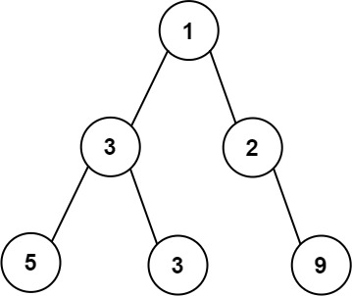
To Overcome the previous problem we can number rows in the row from 1 to n horizontally instead vertically
(Numbering Vertically) (Numbering Horizontally)

To do this we have just substract the mini index of that level to remove next level.
int widthOfBinaryTree(TreeNode* root) {
queue<pair<TreeNode*,int>> q;
q.push({root,0});
int ans = 0;
while(!q.empty()){
int size = q.size();

// 'mini' is the index of the first node at this level
// We subtract it from all other indices in this level
// to "normalize" and prevent overflow
int mini = q.front().second;

// Take the first and last indices at this level
int x = q.front().second; // leftmost node index
int y = q.back().second; // rightmost node index

// Width of this level = rightmost - leftmost + 1
ans = max(ans,y-x+1);

// Process all nodes in the current level
for(int i=0;i<size; i++){
TreeNode* node = q.front().first;
int cnt = q.front().second-mini;
q.pop();
if(node->left) q.push({node->left,2*cnt+1});
if(node->right) q.push({node->right,2*cnt+2});
}
}
return ans;
}

  - Morris Preorder Traversal of a Binary Tree
- Morris Preorder Traversal is a tree traversal algorithm aiming to achieve a space complexity of O(1) without recursion or an external data structure.
- The algorithm should efficiently visit each node in the binary tree in preorder sequence, printing or processing the node values as it traverses, without using a stack or recursion.
PreOrder => Root, Left, Right.

